Mushfique Ahmed

ECE 4363/5363 – Pattern Recognition

Instructor: Dr. Sari-Sarraf

Project 2 – Support Vector Machine

**Description**

This project brings the results of the implementation of Soft-Margin Support Vector Machine with Box Constrains of $0≤ λ_{i}≤C$ in dual form using MATLAB’S convex optimization function **quadprog**. Then, it compares the performance (time taken to complete computation) between this implementation and MATLAB’S own fitcsvm for non-linearly separable cases. The data was generated randomly. Initially a linear decision boundary was fit to the data. Then a non-linear boundary was fit to the same data utilizing the kernel trick via a Gaussian Radial Basis function.

The performance was measured by the time taken by quadprog to calculate the lambda vector vs the time taken for fitcsvm to build the model. Five different dataset sizes were used namely, 100, 200, 300, 400 and 500. 60% of the samples belonged to class 1 and 40% to class 2 for each dataset. An average was taken over five runs for each model and thus the average time taken to complete the computation was plotted.

In the plots below, the samples that are marked as either **Margin** or **Violation** are considered support vectors. The misclassified samples are a subset of the support vectors, particularly, they are a subset of the samples that violate the margins.

**Results**

1. Soft-Margin Linear SVM, C = 0.1. Misclassifications : 9. Support Vectors: 30.

Misclassified examples’ indices: 10 17 20 35 49 65 71 78 81

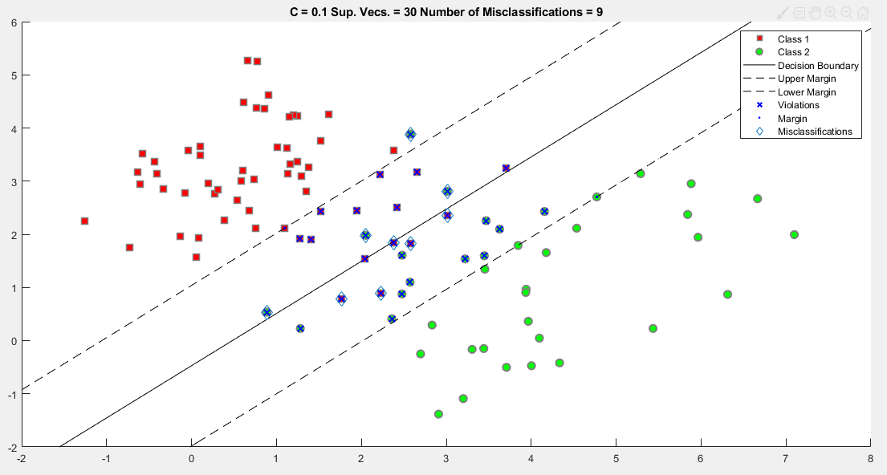

1. Soft-Margin Linear SVM, C = 100. Misclassifications: 7. Support Vectors: 19

Misclassified examples’ indices: 17 20 35 49 65 71 81

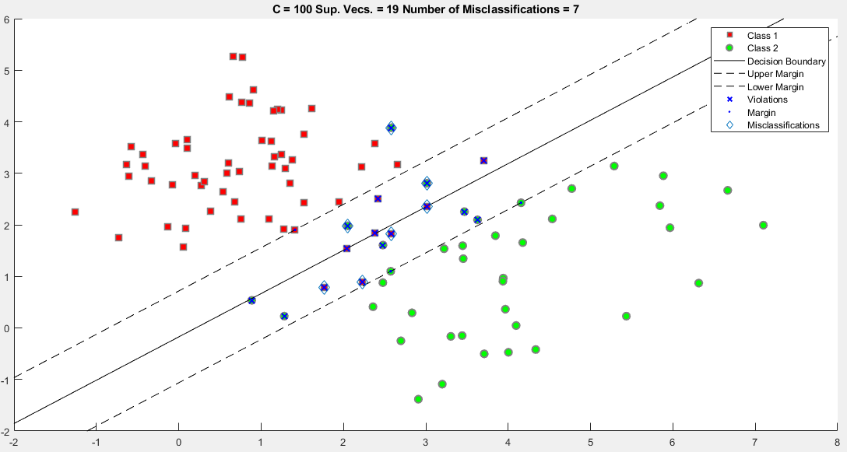

1. Soft-Margin Non-Linear Kernel SVM (RBF), C = 10. Misclassifications: 7. Support Vectors: 22

Misclassified examples’ indices: 14 17 49 65 71 81 91

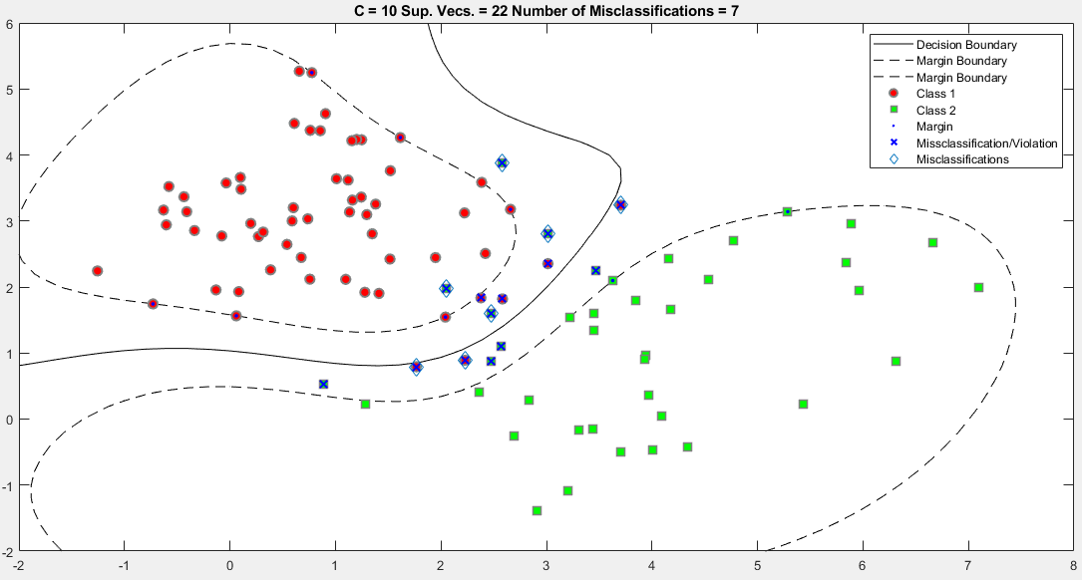

1. Soft-Margin Non-Linear Kernel SVM (RBF). C = 100. Misclassifications: 5. Support Vectors 21

Misclassified examples’ indices: 49 65 71 81 91

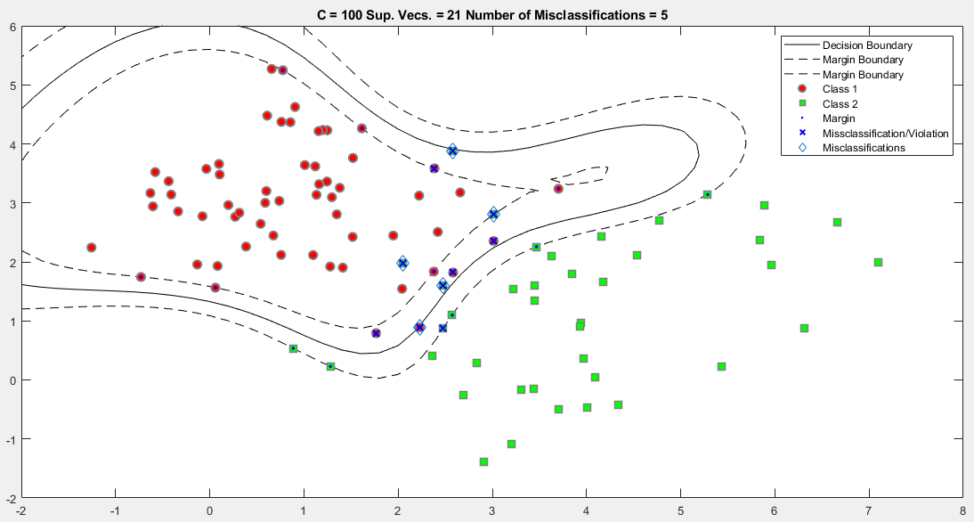

1. Performance curve for fitcsvm(SMO) vs quadprog

